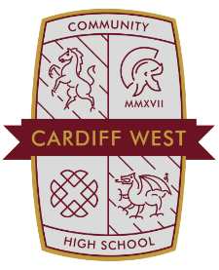
8.12.20
Dear Parents,
Following detailed analysis of the current staffing situation we have had to make a very difficult decision with Year 8. As a result of several COVID related staff absences, we have taken the decision to ask Year 8 to adopt a blended learning approach using MS Teams. This is in line with our Risk Assessment. We apologise for any inconvenience; however, the staffing situation has worsened and we need to rotate Year 7 and 8 in school this week. To compound matters further, it has become increasingly difficult to find supply Teachers because of the current pressures on the system linked to COVID. In simple terms, we were faced with the unprecedented situation of having more than 25 Year 8 lessons that we could not cover today and tomorrow. To this end, we felt it was wise to move to a blended approach and ask your son/daughter to learn safely at home on Thursday 10th and Friday 11th December. Year 8 will return to school as normal on Monday 14t^{h} December 2020. We are reviewing the staffing situation daily to ensure that we keep everyone safe and maintain educational quality. On another note, please ensure that your son/daughter brings their face covering to school every day in line with our Risk Assessment.
Many thanks for your continued support.
Mr. M Hulland
Headteacher.
Cardiff West CHS.

